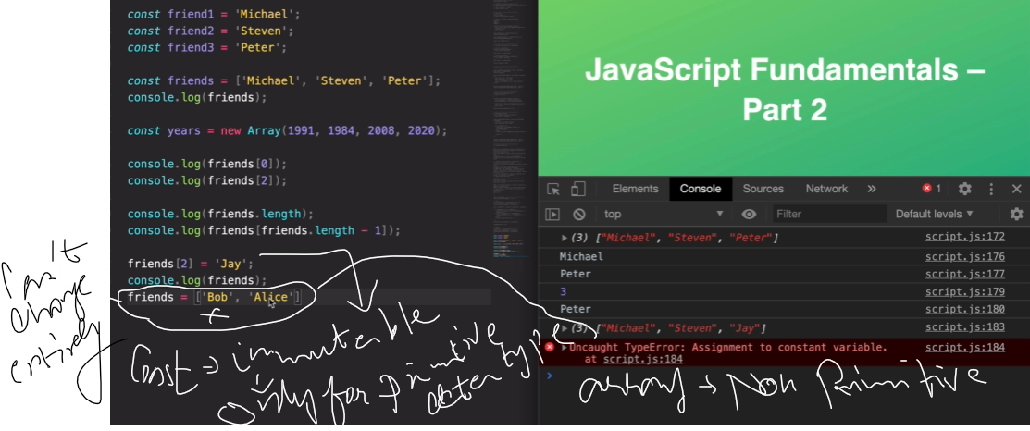

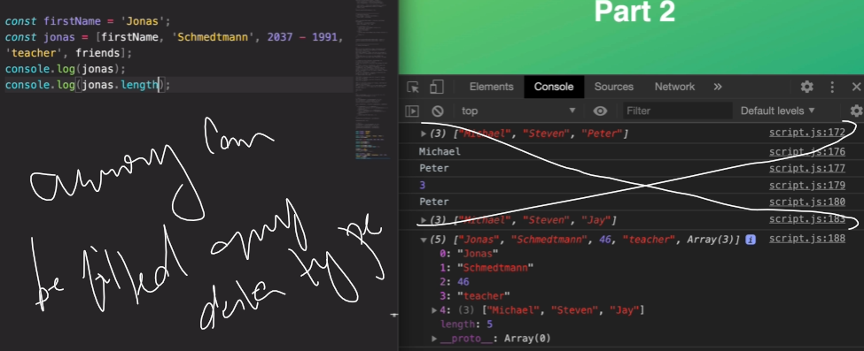

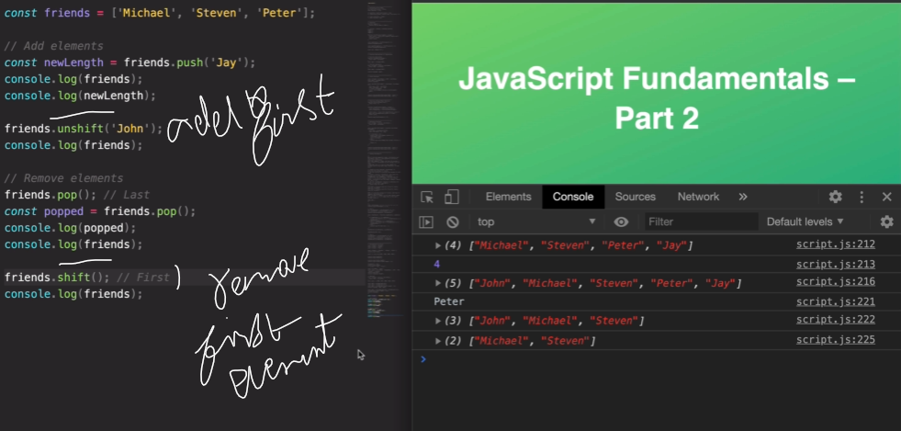

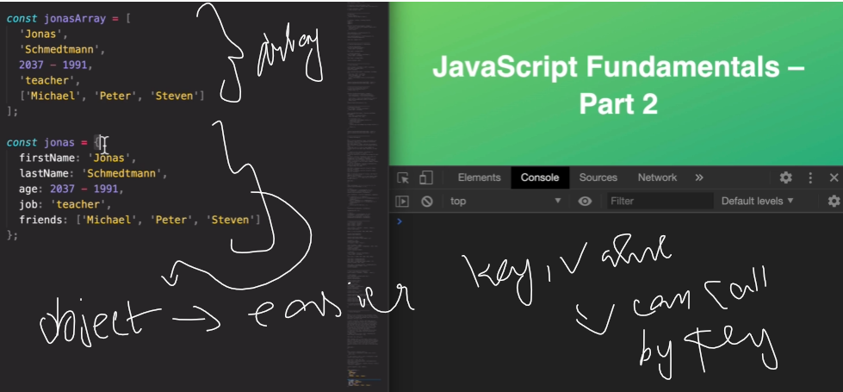

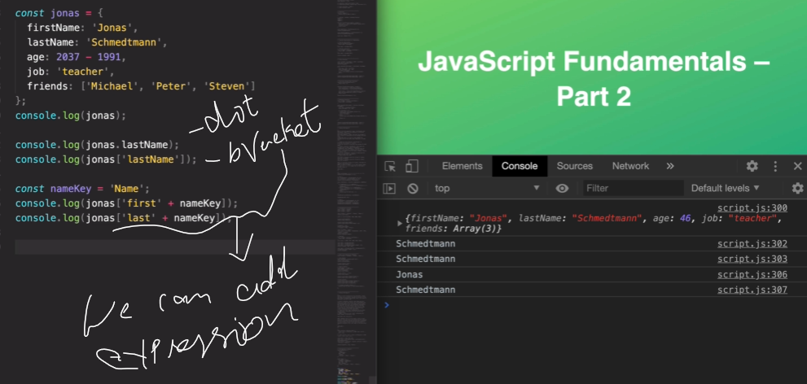

For kind of expression prefer bracket, otherwise prefer dot operation



